Interns KT to Complete Step-by-Step Jetty Installation on EC2 (Port 9090)
This guide helps students:
- Install Eclipse Jetty
- Deploy WAR application
- Change port to 9090
- Create welcome index page
- Access application using Public IP in Amazon Web Services EC2

Step 1 — Launch EC2 Instance
Create Ubuntu EC2 instance.
Recommended:
- Ubuntu 22.04
- t2.micro

Step 2 — Configure Security Group
Add inbound rules:
Type | Port | Source
SSH | 22 | My IP
Custom TCP | 9090 | 0.0.0.0/0
This allows browser access to Jetty.

Step 3 — Connect to EC2
ssh -i your-key.pem ubuntu@PUBLIC-IP
Example:
ssh -i test.pem ubuntu@44.204.200.50

Step 4 — Switch to Root User
sudo su -

Step 5 — Update Server
apt update -y
apt upgrade -y

Step 6 — Install Java
Jetty requires Java.
apt install openjdk-17-jdk -y
Verify:
java -version
Expected:
openjdk version "17"

Step 7 — Create Jetty Directory
mkdir /Jetty
cd /Jetty

Step 8 — Download Jetty
wget https://repo1.maven.org/maven2/org/eclipse/jetty/jetty-home/11.0.20/jetty-home-11.0.20.tar.gz

Step 9 — Extract Jetty
tar -xvf jetty-home-11.0.20.tar.gz
Verify:
ls
Expected:
jetty-home-11.0.20

Step 10 — Create Jetty Base Directory
mkdir jetty-base

Step 11 — Initialize Jetty Base
cd jetty-base
java -jar /Jetty/jetty-home-11.0.20/start.jar --add-modules=http,deploy
Expected folders:
resources
start.d
webapps

Step 12 — Change Port to 9090
Open config:
vi start.d/http.ini
Find:
jetty.http.port=8080
Change to:
jetty.http.port=9090
Save and exit:
- ESC
- :wq

Step 13 — Create Welcome Root Application
cd webapps
mkdir root
cd root

Step 14 — Create Index File
vi index.html
Add:
<html>
<head>
<title>Jetty Application</title>
</head>
<body>
<h1>Welcome to Jetty Server</h1>
<h2>Running on AWS EC2</h2>
<p>DevOps Training Demo</p>
</body>
</html>
Save:
- ESC
- :wq

Step 15 — Deploy WAR File
Copy WAR file into webapps folder.
Example:
cd ..
Now folder should look like:
ls
Expected:
root studentapp.war

Step 16 — Start Jetty Server
IMPORTANT:
Start from jetty-base directory only.
cd /Jetty/jetty-base
java -jar /Jetty/jetty-home-11.0.20/start.jar

Expected:
Started Server
DO NOT close terminal.

Step 17 — Verify Port Listening
Open another terminal.
Check:
ss -tulnp | grep 9090
Expected:
LISTEN 0 50 *:9090

Step 18 — Test Inside Server
wget http://localhost:9090
Should download index page successfully.

Step 19 — Access From Browser
Open:
http://PUBLIC-IP:9090
Example:
http://44.204.200.50:9090

Step 20 — Access WAR Application
http://PUBLIC-IP:9090/studentapp

Run Jetty in Background (Optional)
Instead of foreground:
nohup java -jar /Jetty/jetty-home-11.0.20/start.jar &
Check process:
ps -ef | grep java

Architecture Diagram
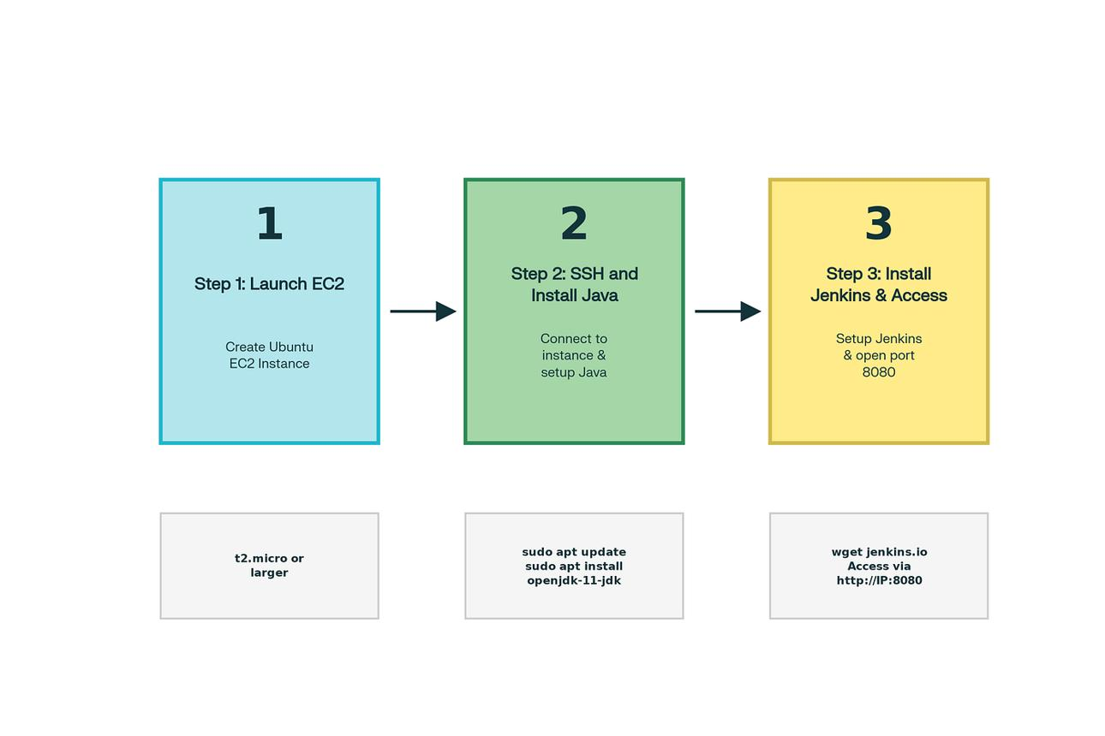
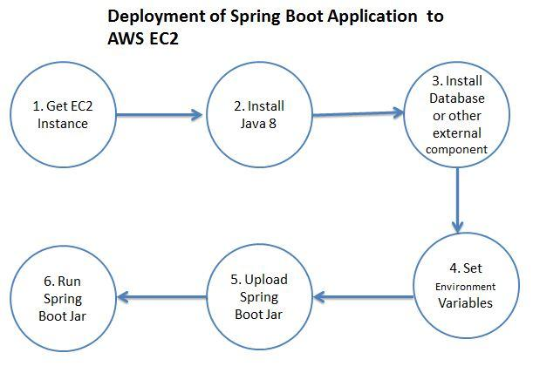
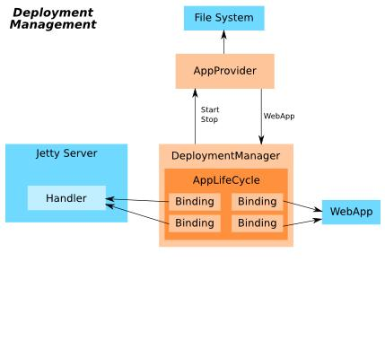
5

Important Concepts for Students
Jetty Home
Contains:
- binaries
- libraries
- start.jar
Example:
/Jetty/jetty-home-11.0.20

Jetty Base
Contains:
- applications
- configs
- deployments
Example:
/Jetty/jetty-base

